**TEAM “John Steinbeck”**

WF Game “Dark Dungeon”

We are:

* Diana Pesheva (dpesheva)
* Qnko Vanov (IankoVanov)
* Petar Petrov (Petur_Petrov)
* Rumen Rumenov (rumen.rumen)
* Stanislav Valkov (smvalkov)
* Tanya Petkova (Tanya)

# Project Description

We have decided to make graphical version using C# as a programming language of the RPG “Dark Dungeons” . The main goal of the game is to navigate the player through the playground and reach the exit. In order to pass the level the player character need to collect all the keys for the locked doors. The challenge is that there is a bad guy looking to kill the player character. We have implemented several levels and three different characters with their own complexity.

The project satisfies completely the general requirements of the assignment.

It has the following elements:

1. **Interfaces**:

* ***IFightable*** – implemented by abstract class ***Character***
* ***IImprovable*** – implemented by abstract class ***Character***
* ***IDefensible*** – implemented by classes ***DefenseItem***, ***Equipment***
* ***ITransactable*** – implemented by class **MoneyBag**
* ***IConsumable*** – implemented by class **Potion**
* ***IDamageDealable*** – implemented by abstract class ***Weapon*** and class ***Equipment***
* ***IWearable*** – implemented by abstract class ***Item*** and class ***Inventory***
* ***IWeightable*** – implemented by abstract class ***Item*** and class ***Inventory***

Required interfaces: **5**, interfaces in app **8**:

1. **Classes**:

* **Data classes**
* ***Enemy***
* ***MazeSolver***
* ***Movement***
* ***PlayerCharacter***
* ***GridViewItem*** – set game field
* ***LevelGrid***
* ***Position*** – set position of items, player character , enemies
* ***DefenceItem*** – implements defensive items
* ***Equipment***
* ***Inventory***
* ***ItemsCollection*** – implements item collection for the hero
* ***MoneyBag*** – implement money bag
* ***HealthPotion*** – implements health potion
* ***ManaPotion*** – implements mana potion
* ***PotionsCollection*** – implements potion collection
* ***StrengthPotion***
* ***Key***
* ***Player*** – set current player
* ***ShortLogic***
* **GUI classes**
* ***ButtonClickEvents***
* ***CharacterSelectMenuScreen***
* ***Level*** – initialize current map level, set pictures
* ***LoadMenuScreen*** – shows menu screen
* ***MainMenuScreen*** – shows buttons
* ***MenuScreen***
* ***PauseMenuScreen***
* ***SaveMenuScreen -*** saves current game status
* ***Start***
* ***Window***

Required Classes: **15**, Classes in app: **29**: **19** in Data part and **10** in GUI part

1. **Abstract Classes**:

* ***Item*** – sets item properties
* ***Weapon*** – implements weapons
* ***Character*** – sets character properties
* ***Potion*** – implements potions
* ***Executable***

Required Abstract Classes: **3**, in app: **4**

1. **Exception Classes:**

* ***GameEndException***

Required exception classes: **1**, Exception classes in app: **1**

1. **Levels of depth in inheritance:**

* for Example: ***HealthPotions*** inherits ***Potion***, which inherits ***Item***, which inherits ***GridViewItem***

Required levels of depth in inheritance: **3**, Levels of depth in inheritance in app: **3**

1. **Structures:**

* ***Square***
* ***HealthBar***

Required structures: **1**, Structures in app: **2**

1. **Enumerations:**

* ***Direction***
* ***Images***

Required enumerations: **1**, Enumerations in app: **2**

1. **Events:**

* ***NewGameClick***
* ***KnightKlick***
* ***MarksmanKlick***
* ***MageKlick***
* ***SaveGameClick***
* ***SaveToSlot1Click***
* ***SaveToSlot2Click***
* ***SaveToSlot3Click***
* ***SaveMenuBackClick***
* ***LoadGameClick***
* ***LoadSlot1Click***
* ***LoadSlot2Click***
* ***LoadSlot3Click***
* ***LoadMenuBackClick***
* ***ResumeGameClick***
* ***HighScoresClick***
* ***HelpClick***
* ***ToMainMenuClick***
* ***ExitClick***

Required events: **1**, Events in app: **19**

1. **Design Patterns:**

* ***Abstract Factory***

Required design patterns: **1**, Design patterns in app: **1**

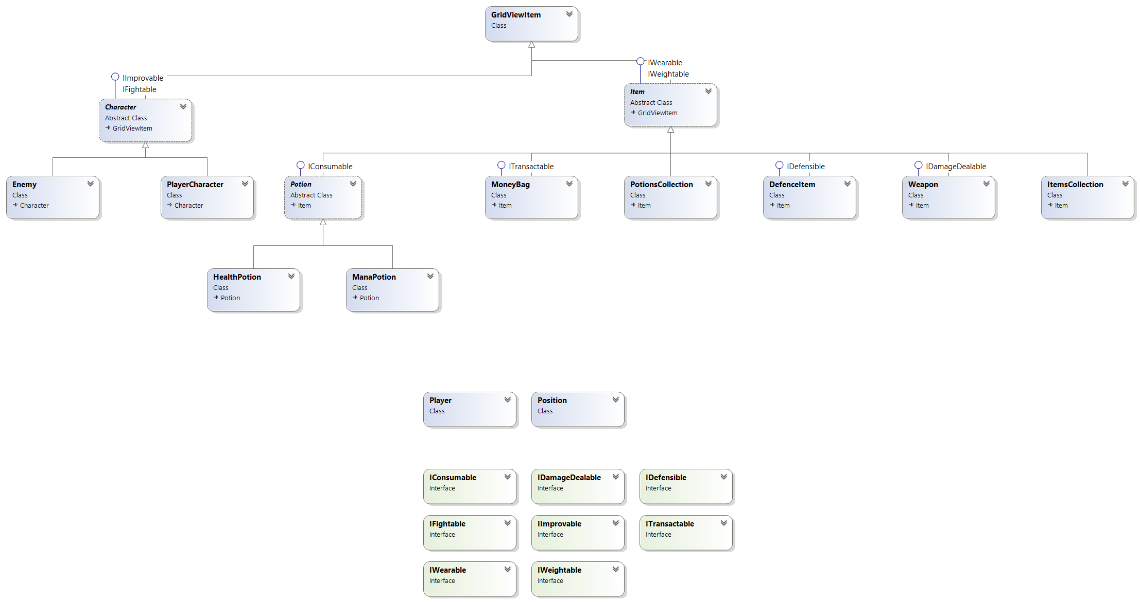

The URL of our repository is: <https://github.com/RazorDude/OOPTeamwork.git>